**Nanoparticles1 experiment AuNP in CT scan**

As the first step in the lab, I injected all holes (91holes) with AuNP (0.05 mg/ml) and started with holes 7mm to 4mm (13ml AuNP and 107ml water as a solution). Then I went to the MGNG centre at Royal Devon and Exeter Hospital to do a CT scan.

|  |  |  |  |  |  |  |  |  |  |  |  |  |
| --- | --- | --- | --- | --- | --- | --- | --- | --- | --- | --- | --- | --- |
| **7mm** |  |  |  |  |  |  |  |  |  |  |  |  |
| **6.5mm** |  |  |  |  |  |  |  |  |  |  |  |  |
| **6mm** |  |  |  |  |  |  |  |  |  |  |  |  |
| **5.5mm** |  |  |  |  |  |  |  |  |  |  |  |  |
| **5mm** |  |  |  |  |  |  |  |  |  |  |  |  |
| **4.5mm** |  |  |  |  |  |  |  |  |  |  |  |  |
| **4mm** |  |  |  |  |  |  |  |  |  |  |  |  |

**How to calculate AuNPs with water! As a solution**

**V= Pi**

**V= 3.145cm3.52,….=V/100**

**7mm=1.92 13=25ml**

**6.5mm=1.65 13=21.45ml**

**6mm=1.41 13=18.33ml**

**5.5mm=1.18 13=15.34ml**

**5mm=0.98 13=12.74ml**

**4.5mm=0.79 13=10.27ml**

**4mm=0.62 13=8.06ml**

**Total = 111.19**

**The concentration with solution=0.05*13/120=0.0054mg/ml**

**Figure1 Figure2**

**Figure3 Figure4**

**Figure5**

**Methods**

Quantitative and qualitative methods are various methodologies used to analyse and interpret the imaging data produced from a CT scan.

**Quantitative methods:**

* E=−∑i=0P(i)⋅log2​(P(i)) using by MATLAB software

|  |  |  |  |  |  |
| --- | --- | --- | --- | --- | --- |
| KvP  Rotation time | **70** | **80** | **100** | **120** | **140** |
| **0.5** | **Image1** | **Image2** | **Image3** | **Image4** | **Image5** |
| **1** | **Image6** | **Image7** | **Image8** | **Image9** | **Image10** |
| **0.5** | **Image1** | **Image2** | **Image3** | **Image4** | **Image5** |
| **1** | **Image6** | **Image7** | **Image8** | **Image9** | **Image10** |

**Images**

**70 Kvp ,0.5s, 215**

**70 Kvp ,1s , 215**

**80 Kvp ,0.5s, 215**

**80 Kvp ,1s, 215**

**100 Kvp ,0.5s, 215**

**100 Kvp , 1s, 215**

**120 Kvp ,0.5s, 215**

**120 Kvp , 1s, 215**

**140 Kvp ,0.5s, 215**

**140 Kvp , 1s, 215**

**70 Kvp ,0.5s, 429**

**70 Kvp ,1s , 429**

**80 Kvp ,0.5s, 429**

**80 Kvp ,0.5s, 429**

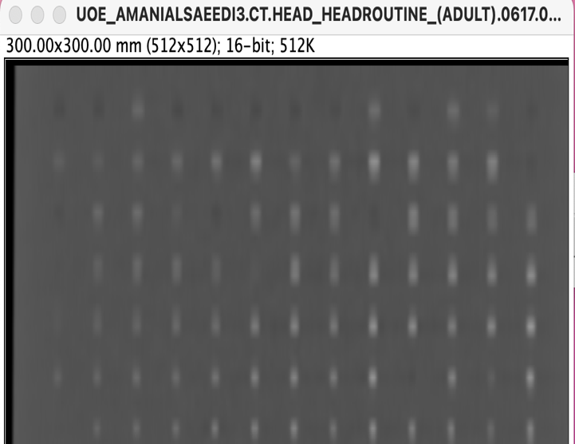

**100 Kvp ,0.5s, 429**

**100 Kvp ,1s, 429**

**120 Kvp ,0.5s, 429**

**120 Kvp ,1s, 429**

**140 Kvp ,0.5s, 429**

**140 Kvp ,1s, 429**

**Results**

1. **CNR with AuNPs**

**2-Entropy with AuNPs**

I tried to write a coding to calculate an entropy value using a MATLAB software.

Firstly, I converted the better images into tiff format. Then I built a new folder these images. Finally, I wrote a code below inside a MATLAB.

clc

clear

I=imread('80KvpRT0.5.tif');

J=entropyfilt(I);

figure

imshow(J,[]);

title('result of entropy filtering 80Kvp');

e80KvP=entropy(I);

**Entropy results**

Entropy 80 KvP 0.5 Rotation time was 1.23

Entropy 80 KvP 1 Rotation time was 1.27

Entropy 100 KvP 0.5 Rotation time was 1.271

Entropy 100 KvP 1 Rotation time was 1.34

Entropy 120 KvP 0.5 KvP Rotation time was 1.34

Entropy 120 KvP 1 KvP Rotation time was 1.31

Entropy 140 KvP 0.5 KvP Rotation time was 1.27

Entropy 140 KvP 1 KvP Rotation time was 1.27